Immaculate Conception Parish

P O BOX 600 Tumut
Catholic Community
Collection amounts for January 2016 ~PARISH NEWS~
~ PARISH NEWS ~
~ GOSPEL REFLECTION ~

In Mark’s gospel, we often find a story within a story. Some scholars refer to this technique as the making of a Markan sandwich, others as a framing device. In Mark 5:21-43, the frame consists of the two-part story of the desperately ill twelve year old daughter of Jairus, a synagogue official. Jairus falls at the feet of Jesus in an attitude of reverence and pleads with him to come and lay hands on her. Jesus is clearly known as a healer, one who can “save” life. The passage closes with the young woman’s seeming death and restoration to life. In between, we have the story of an older woman, also seriously ill, possibly with a gynaecological problem: she has been haemorrhaging for twelve years.

The stories are linked in many ways, first by the repetition of the number twelve-a symbolic number in a Jewish context. Both the young Jewish woman and the older Jewish woman are in need of the saving power of God mediated through Jesus the healer. Later in the Markan story [7:24-30) a Gentile mother and daughter will beg for and receive that same saving power of God. Jairus’ daughter does not speak for herself. Like all young women of that culture, ill or not, she is dependent on the voice of her father. The older woman comes tentatively “from behind”. She speaks, but only to herself, as she touches Jesus’ cloak and, through this touch, experiences healing in her body. Does the healing power of God suffuse even the fabric of Jesus’ cloak? The woman is finally shamed into telling all. Like Jairus, she falls at the feet of Jesus.

Jairus refers to his little girl on the brink of adulthood as “my daughter”. Jesus addresses the older woman as “my daughter”. Both women, the younger and the older, are daughters of Israel. Both are restored to health, one on account of her parents’ faith (the unnamed mother and the named father], the other because of her own faith. Jesus the healer has embraced and responded to the pain of a woman alone on the one hand and of a family (mother, father, and daughter) on the other.

An excerpt by Sr. Veronica Lawson

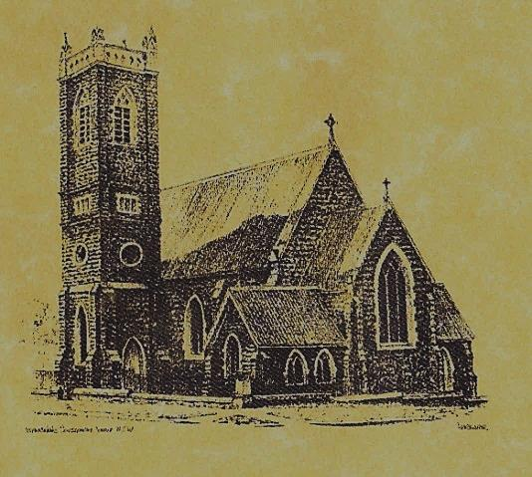

‘CLERGY’
- Fr. Sijo Jose (Parish Priest)
- Fr. George Ogah (Assistant Priest)

‘PARISH SECRETARY’
Anna Quinn
Phone: 02 69474599
Fax: 02 69474602
Email: tumut@cg.org.au
Web: www.cg.org.au/tumut
Office hours: Wednesday & Friday 9am -12noon
-------------------------------------------------------- ‘WEEKEND MASS TIMES’
Saturday Vigil: 6.pm
Sunday: 10am

‘THIS WEEKS MASS TIMES’
Tuesday: 6pm in Chapel
Wednesday: 10am (School Mass)
Thursday & Friday: 8am in Chapel
Saturday: 9am (every fortnight – Thursday: 11am BUPA Liturgy Saturday: 9.40am BLAKENEY LODGE Liturgy)
‘ROSARY’
Saturday at 8.45am Exposition at 8.30am (1st Sat of month)
‘RECONCILIATION’
Saturday at 5.15pm
‘LITURGY MEETING’
Tuesday: 2.00pm in Chapel
‘PRAYER GROUP’
(Rosary & Divine Mercy)
Wednesday: 2.00pm in Chapel
‘CONTACTS’
Care Group: Anne Huebner 69473406

13th Sunday in Ordinary Time Year B
July 1st 2018

Entrance Antiphon
All peoples, clap your hands. Cry to God with shouts of joy!
Responsorial Psalm
I will praise you, Lord, for you have rescued me.
Gospel Acclamation
Alleluia, alleluia! Our Saviour Jesus Christ has done away with death and brought us life through his gospel. Alleluia!

Gospel Acclamation
-----------------------------------
Alleluia, alleluia! Tomorrow the wickedness of the earth will be destroyed; the Saviour of the world will be our king. Alleluia!

T THIS WEEK Saturday & Sunday 30th June & 1st July

Ministry | Saturday Vigil 6pm | Sunday 10am
Acolyte | Tony Butler | Mark Hogan
Reader | Dobbie Family | Sue Bulger
Commentator | Dobbie Family | John Power
Children’s Liturgy | ---------- | Kerrin Henderson
Musicians | Patricia & Monica | Anna Quinn
Altar Servers | New Servers | Abby Crampton & Olivia Dean
Church Care  ________________________  LINEN Bev Piper | ----------------------------------------
NEXT WEEK Saturday & Sunday 7th & 8th July
Ministry | Vigil 6pm |  | 10am
Acolyte | Peter Malone |  | Dave Shedden
Reader | Anita Mason |  | Howard Young
Commentator | Anne Huebner |  | Mary Kelly
Children’s Liturgy | ---------- |  | Caitlin Larter
Musicians | Patricia & Monica |  | Anna Quinn
Altar Servers | Xavier Henderson & Riley Hotham |  | Jessica & Emily Kelly
Church Care | Group 2: Anna, Pat, Sophie, Fabiana & Richard Fox
Feast DayWishing all our wonderful dads a Happy In m FEAST DAY 3rd July: Saint Thomas
R O S T E R S
‘Yet all is not lost. Human beings, while capable of the worst, are also capable of rising above themselves, choosing again what is good, and making a new start.’
(Pope Francis)
~PARISH NEWS ~
PLAN GIVING ENVELOPES for 2018-19 are now available. Please collect your package from the church foyer. If any family or individual would like to join our plan giving please contact Anna at the Presbytery. We sincerely thank all our generous givers for their continued support. TALBINGO MASS is in recess during the winter months and will resume in October. WORKING WITH CHILDREN CHECK all Acolytes and Special Ministers are required to obtain a volunteer certificate. Could you please attend to this matter asap. If you have one, please bring it into the presbytery so it can be copied and forwarded to Canberra. MANY THANKS to our faithful Acolytes this weekend Tony Butler & Mark Hogan
~ ~ ~

We pray for those who have gone before us marked with the sign of faith:
MASS HAS BEEN REQUESTED FOR:

Andrew Sturt., Chris Ballard, Brian Rosetta, Paul Kelly, Sr. Valerian, Gus & Kath Clout, Ab & Mildred Shanahan, Ina Clout, Marion, Kev & Bill Smith, Pat Malone, Joan Malone, Frank Delany, Ken & Brian Gee, Mazx Butler, Imelda, Bede & Francis McInerney, Cecilia Haddah, John Hourigan, Russell & Peter Ritchie, Kerry Letts, Filomena Comai, Eileen Creighton, Muriel Maidwell, Thomas Maidwell, Margaret Anne Reardon, Steph Scott, Peter Bush, Alan Guthrie, Jim McInerney, Kath Stuckey, Iris Stuckey, Minnie Murphy, Alfred & Bridget Claffey, John Marzol, Joan & Pat Cronmy, Sean Gordon, Maureen Ashleigh, Kade Adams, Tom Sturt, Winifred Whitacker, Edward,Mary & Clem Malone, Pat Malone, Hickson & O’Sullivan families, Colleen Anderson, Reg & Mary Madigan, Matt Downing, Wilkinson & Downing families, Frank Stanfield, Peter Heffernan, Tim & Amy Twomey, Barbara Fuller, Tom & Merle Arentz, Harriet & Ruben Arentz, Kevin & Nola Arentz, Dulcie & Arthur Piper, Marie & Ray Cowan, Kevin Cowan, Kevin Hawthorne, Natalie Baker, Ian Barbour, Fr. Peter Quirk, Con & Ennis Twomey, Mons.John Twomey, Sr. M. Brenda Twomey, Sr. M. Canice O’Sullivan, Sr. M. Celine McCormack, Bert & Teresa Butler, Anne Lawrance, Joan & Bob Liddell, Mary & William Claffey, Ruby Harmer, Hassel & Joy McGrath, Noel Cook, Frederick & Mabel McInerney, James Kelly, Tom & Dorothy French.

